# Statistical Inference

## Course Project

### Inference Exercies

Now in the second portion of the class, we're going to analyze the ToothGrowth data in the R datasets package.

Let's load the dataset first and take a look at it.

data(ToothGrowth)  
print(head(ToothGrowth))

## len supp dose  
## 1 4.2 VC 0.5  
## 2 11.5 VC 0.5  
## 3 7.3 VC 0.5  
## 4 5.8 VC 0.5  
## 5 6.4 VC 0.5  
## 6 10.0 VC 0.5

There are three variables in the dataset: Tooth length, Supplement type (VC or OJ) and Dose in milligrams.

Let's graph the data 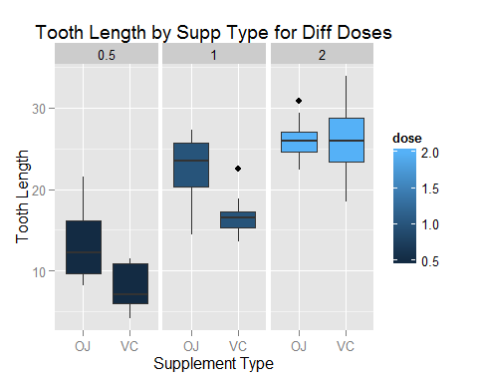 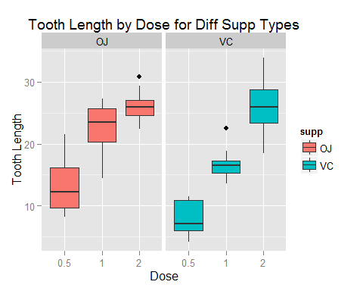

Now we will use confidence intervals and/or hypothesis tests to compare tooth growth by supp and dose. We will be assuming equal variances in the samples throughout the analysis.

Is there a difference between two delivery methods at different dose levels. Let's construct confidence intervals at 95% level assuming constant variance.

##   
## Welch Two Sample t-test  
##   
## data: len by supp  
## t = 3.1697, df = 14.969, p-value = 0.006359  
## alternative hypothesis: true difference in means is not equal to 0  
## 95 percent confidence interval:  
## 1.719057 8.780943  
## sample estimates:  
## mean in group OJ mean in group VC   
## 13.23 7.98

As evident in the above, zero is not in the 95% confidence interval. Therefore, when the dose is 0.5, there is a significant difference in tooth length between the two delivery methods.

In this example, when the dose is 1.0, we also observe significant difference in tooth length between the two delivery methods. The 95% confidence interval is 2.8; 9.06.

However, when the dose is 2.0, we find no significant difference in tooth length by the delivery method at the 95% confidence level.The 95% confidence interval is -3.80; 3.64. As we can see, zero falls in the 95% confidence interval.

Now we will test if there is any difference in tooth length by dose within the same delivery method.

Within the OJ delivery method, there is a significant difference (at 95% significance level) in tooth length when the doses are 0.5 and 1.0. The 95% confidence interval is -11.27; -6.31

The difference is also significant when the doses are 1.0 and 2.0. The 95% confidence interval is -13.05; -5.69

The difference in tooth length when the delivery method is OJ is also significant for doses 0.5 and 1.0 at 95% confidence level (-13.42;-5.52)

The difference is also significant for the doses 1.0 and 2.0.(95% confidence interval is -6.53; -0.19)